Ticket Id 38754

Subject: My Options: Not available when login as Admin, Curator, or Contributor

Entered by: Isabelle
Date: 11/16/06
Addressed to: Ellen

Steps to reproduce:
- Launch Dataverse Network and create three accounts: e.g. Isabelle, Simone, Leonid
- Log in as Network Admin and go to a Dataverse, e.g. Albert Camus
- Go to My Options > Set Site Restrictions and User Privileges
- Add user Isabelle as Admin, Simone as Curator, and Leonid as Contributor one at a time
- Log in as Admin and go to My Options (there is no My Options) then log out
- Log in as Curator and go to My Options (there is no My Options) then log out
- Log in as Contributor and go to My Options (there is no My Options) then log out

Result: The My Options link does not display for either one of these roles

Should be: My Options should display for Admin, Curator, and Contributor

Screen captures

See next page..

Edit Privileged Users by Network Admin (Network Dataverse)

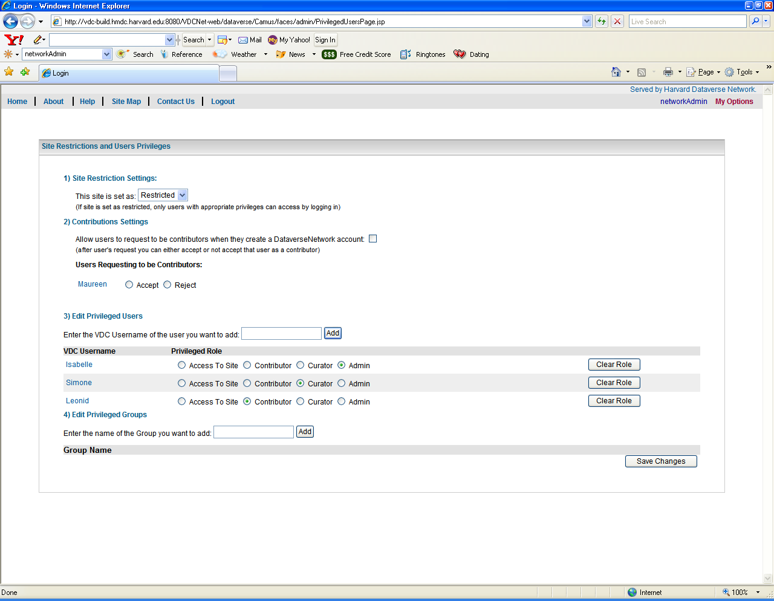

See next page..

Admin, Curator, or Contributor Login (Dataverse)

